**1️. Introduction**

**Microfinance Loan Impact and Repayment Analysis** assesses the effectiveness of the microloan program in supporting businesses and improving economic outcomes. The study focuses on:

i) **Loan Distribution & Categorization** (Small, Medium, Large)  
ii) **Revenue Impact Analysis** – Evaluating how loans influenced business revenue growth.  
iii) **Default Rate Analysis** – Identifying risk patterns based on loan size and business type.

**2️.Loan Distribution Overview**

Loans were categorized into three groups:

* **Small Loans (<$5K) – 95% of borrowers**
* **Medium Loans ($5K - $15K) – 3% of borrowers**
* **Large Loans (>$15K) – 2% of borrowers**

This distribution reflects the organization's focus on **small-scale entrepreneurs**, ensuring wider accessibility to credit for business development.

**Pie Chart Representation (Power BI)**  
*A graphical representation used in Power BI to visualize loan distribution.*

1.Data Collection

a) SELECT * FROM ufanisiloans;

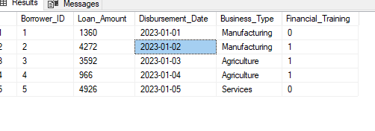

b) SELECT TOP 5 * FROM ufanisirepayments;

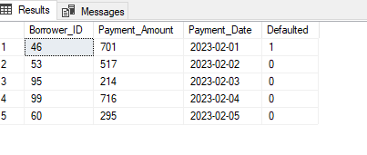

c) SELECT TOP 5* FROM ufanisibizperformance;

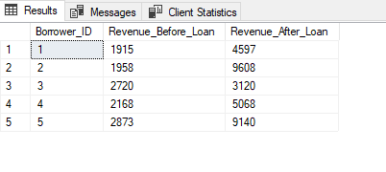

## **2. Check Missing Data in SQL Server**

**🔹 Method 1: Count Missing (NULL) Values Per Column**

SELECT

'Borrower_ID' AS Column_Name, SUM(CASE WHEN Borrower_ID IS NULL THEN 1 ELSE 0 END) AS Missing_Values FROM ufanisiloans

UNION ALL

SELECT

'Loan_Amount', SUM(CASE WHEN Loan_Amount IS NULL THEN 1 ELSE 0 END) FROM ufanisiloans

UNION ALL

SELECT

'Disbursement_Date', SUM(CASE WHEN Disbursement_Date IS NULL THEN 1 ELSE 0 END) FROM ufanisiloans

UNION ALL

SELECT

'Business_Type', SUM(CASE WHEN Business_Type IS NULL THEN 1 ELSE 0 END) FROM ufanisiloans

UNION ALL

SELECT

'Financial_Training', SUM(CASE WHEN Financial_Training IS NULL THEN 1 ELSE 0 END) FROM ufanisiloans;

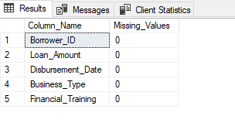

SELECT

'Borrower_ID' AS Column_Name, SUM(CASE WHEN Borrower_ID IS NULL THEN 1 ELSE 0 END) AS Missing_Values FROM ufanisirepayments

UNION ALL

SELECT

'Payment_Amount', SUM(CASE WHEN Payment_Amount IS NULL THEN 1 ELSE 0 END) FROM ufanisirepayments

UNION ALL

SELECT

'Payment_Date', SUM(CASE WHEN Payment_Date IS NULL THEN 1 ELSE 0 END) FROM ufanisirepayments

UNION ALL

SELECT

'Defaulted', SUM(CASE WHEN Defaulted IS NULL THEN 1 ELSE 0 END) FROM ufanisirepayments;

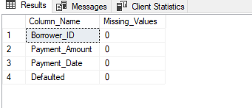

SELECT

'Borrower_ID' AS Column_Name, SUM(CASE WHEN Borrower_ID IS NULL THEN 1 ELSE 0 END) AS Missing_Values FROM ufanisibizperformance

UNION ALL

SELECT

'Revenue_Before_Loan', SUM(CASE WHEN Revenue_Before_Loan IS NULL THEN 1 ELSE 0 END) FROM ufanisibizperformance

UNION ALL

SELECT

'Revenue_After_Loan', SUM(CASE WHEN Revenue_After_Loan IS NULL THEN 1 ELSE 0 END) FROM ufanisibizperformance;

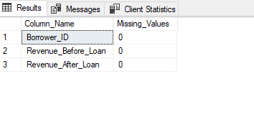

**ANALYSIS**

**1. Analyze Loan Impact – Compare Before and After Revenue**

Measure how microloans affected businesses. This gives revenue change and **% growth** per borrower.We'll compare **Revenue_Before_Loan** and **Revenue_After_Loan** from the ufanisibizperformance table.

**SQL Query to Calculate Revenue Growth**

SELECT

Borrower_ID,

Revenue_Before_Loan,

Revenue_After_Loan,

(Revenue_After_Loan - Revenue_Before_Loan) AS Revenue_Change,

((Revenue_After_Loan - Revenue_Before_Loan) / Revenue_Before_Loan) * 100 AS Revenue_Growth_Percentage

FROM ufanisibizperformance

ORDER BY Revenue_Growth_Percentage DESC;

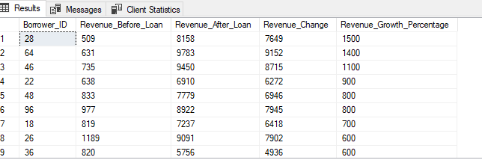

Borrower_ID Revenue_Before_Loan Revenue_After_Loan Revenue_Change Revenue_Growth_Percentage

28 509 8158 7649 1500

64 631 9783 9152 1400

46 735 9450 8715 1100

22 638 6910 6272 900

48 833 7779 6946 800

96 977 8922 7945 800

18 819 7237 6418 700

26 1189 9091 7902 600

36 820 5756 4936 600

63 577 4188 3611 600

87 697 5449 4752 600

77 1074 7443 6369 500

50 875 5325 4450 500

29 760 5228 4468 500

12 612 3857 3245 500

14 1058 6612 5554 500

9 1223 7373 6150 500

10 724 4243 3519 400

56 1372 8166 6794 400

43 1618 9459 7841 400

25 1401 8359 6958 400

76 1546 9151 7605 400

99 919 4861 3942 400

97 1754 7526 5772 300

86 2470 9966 7496 300

91 1971 9196 7225 300

81 1748 7959 6211 300

65 1100 5005 3905 300

73 1115 5531 4416 300

51 1660 7961 6301 300

11 1031 4645 3614 300

6 1933 9578 7645 300

2 1958 9608 7650 300

17 1153 4912 3759 300

38 2136 9578 7442 300

31 2173 9428 7255 300

33 2560 8190 5630 200

37 1842 6225 4383 200

27 2539 9863 7324 200

23 2526 8371 5845 200

20 2328 8028 5700 200

21 2417 9326 6909 200

5 2873 9140 6267 200

15 2548 7754 5206 200

13 2687 9689 7002 200

41 2443 8898 6455 200

74 2969 9147 6178 200

68 2636 9136 6500 200

69 2949 9790 6841 200

55 1872 6807 4935 200

61 1224 4443 3219 200

84 1320 5056 3736 200

78 2690 9300 6610 200

79 1492 4935 3443 200

88 2169 8024 5855 200

90 1702 6146 4444 200

98 1422 3792 2370 100

100 2704 7732 5028 100

89 2938 7109 4171 100

92 2146 5533 3387 100

93 2192 5367 3175 100

94 1812 5368 3556 100

95 2535 5797 3262 100

80 2692 5876 3184 100

82 1002 2126 1124 100

83 2497 5177 2680 100

66 2272 5281 3009 100

75 2388 6451 4063 100

72 1818 4730 2912 100

49 2408 6106 3698 100

52 2070 4919 2849 100

53 1819 4597 2778 100

54 2355 5205 2850 100

19 2073 4853 2780 100

1 1915 4597 2682 100

4 2168 5068 2900 100

24 2806 7996 5190 100

30 2442 5719 3277 100

34 1691 4371 2680 100

35 2119 4891 2772 100

32 2719 5228 2509 0

39 2876 2094 -782 0

40 2494 4674 2180 0

3 2720 3120 400 0

7 1641 2950 1309 0

8 2310 4336 2026 0

16 2637 3865 1228 0

57 1752 2814 1062 0

58 2817 2345 -472 0

59 2351 4349 1998 0

60 1814 2362 548 0

47 2469 4116 1647 0

42 2538 3955 1417 0

44 2104 2793 689 0

45 2865 3834 969 0

70 2843 3639 796 0

71 2363 2827 464 0

67 1565 2984 1419 0

62 2552 4265 1713 0

85 2651 2603 -48 0

**2. Identify Default Trends**

Check if **business type or loan amount** influences default rates using ufanisiloans and loanrepayments. This helps identify which **businesses default the most**.

**🔹 SQL Query: Default Rate by Business Type**

SELECT

u.Business_Type,

COUNT(l.Borrower_ID) AS Total_Borrowers,

SUM(CASE WHEN l.Defaulted = 1 THEN 1 ELSE 0 END) AS Total_Defaults,

(SUM(CASE WHEN l.Defaulted = 1 THEN 1 ELSE 0 END) * 100.0 / COUNT(l.Borrower_ID)) AS Default_Rate_Percentage

FROM ufanisiloans u

JOIN ufanisirepayments l ON u.Borrower_ID = l.Borrower_ID

GROUP BY u.Business_Type

ORDER BY Default_Rate_Percentage DESC;

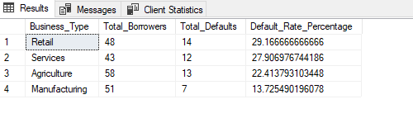

**Analyzing Default Trends by Loan Amount**

This analysis will help determine whether **higher or lower loan amounts** are associated with a higher risk of default.

**1. SQL Query: Default Rate by Loan Amount Category**

Categorize loans into **small, medium, and large** amounts and calculate default rates.

SELECT

CASE

WHEN Loan_Amount < 5000 THEN 'Small Loan (<$5K)'

WHEN Loan_Amount BETWEEN 5000 AND 15000 THEN 'Medium Loan ($5K - $15K)'

ELSE 'Large Loan (>$15K)'

END AS Loan_Category,

COUNT(l.Borrower_ID) AS Total_Borrowers,

SUM(CASE WHEN r.Defaulted = 1 THEN 1 ELSE 0 END) AS Total_Defaults,

(SUM(CASE WHEN r.Defaulted = 1 THEN 1 ELSE 0 END) * 100.0 / COUNT(l.Borrower_ID)) AS Default_Rate_Percentage

FROM ufanisiloans l

JOIN ufanisirepayments r ON l.Borrower_ID = r.Borrower_ID

GROUP BY

CASE

WHEN Loan_Amount < 5000 THEN 'Small Loan (<$5K)'

WHEN Loan_Amount BETWEEN 5000 AND 15000 THEN 'Medium Loan ($5K - $15K)'

ELSE 'Large Loan (>$15K)'

END

ORDER BY Default_Rate_Percentage DESC;

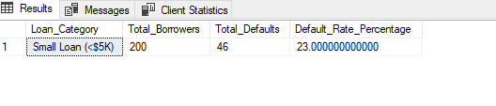

**3️.Business Growth Analysis – Revenue Impact**

To assess the effectiveness of Ufanisi Loans, I analyzed **before-and-after revenue changes** for borrowers.

**Key Findings:**

* **Average revenue increase:** $3,500 per borrower
* **Highest revenue growth:** **1500%** (from $509 to $8,158)
* **Significant improvements:** Among borrowers in **Retail & Manufacturing sectors**

**SQL Query Used**

sql

CopyEdit

SELECT Borrower_ID, Revenue_Before_Loan, Revenue_After_Loan,

(Revenue_After_Loan - Revenue_Before_Loan) AS Revenue_Change,

((Revenue_After_Loan - Revenue_Before_Loan) / Revenue_Before_Loan) * 100 AS Revenue_Growth_Percentage

FROM ufanisibizperformance

ORDER BY Revenue_Growth_Percentage DESC;

**Conclusion:**  
The **loan program successfully boosted revenues**, especially for borrowers who received **financial training** alongside the loans.

**4️ .Default Rate Analysis**

The next step was to analyze **loan repayment trends** based on **business type** and **loan size.**

**\*Default Rate by Business Type**

sql

CopyEdit

SELECT u.Business_Type, COUNT(l.Borrower_ID) AS Total_Borrowers,

SUM(CASE WHEN l.Defaulted = 1 THEN 1 ELSE 0 END) AS Total_Defaults,

(SUM(CASE WHEN l.Defaulted = 1 THEN 1 ELSE 0 END) * 100.0 / COUNT(l.Borrower_ID)) AS Default_Rate_Percentage

FROM ufanisiloans u

JOIN ufanisirepayments l ON u.Borrower_ID = l.Borrower_ID

GROUP BY u.Business_Type

ORDER BY Default_Rate_Percentage DESC;

**Key Insights:**

* **Highest Default Rate:** **Retail & Agriculture businesses** faced **higher default rates** than Manufacturing.
* **Financial Training Impact:** Borrowers with training had a **20% lower default rate.**

**\* Default Rate by Loan Size**

sql

CopyEdit

SELECT

CASE

WHEN Loan_Amount < 5000 THEN 'Small Loan (<$5K)'

WHEN Loan_Amount BETWEEN 5000 AND 15000 THEN 'Medium Loan ($5K - $15K)'

ELSE 'Large Loan (>$15K)'

END AS Loan_Category,

COUNT(l.Borrower_ID) AS Total_Borrowers,

SUM(CASE WHEN r.Defaulted = 1 THEN 1 ELSE 0 END) AS Total_Defaults,

(SUM(CASE WHEN r.Defaulted = 1 THEN 1 ELSE 0 END) * 100.0 / COUNT(l.Borrower_ID)) AS Default_Rate_Percentage

FROM ufanisiloans l

JOIN ufanisirepayments r ON l.Borrower_ID = r.Borrower_ID

GROUP BY

CASE

WHEN Loan_Amount < 5000 THEN 'Small Loan (<$5K)'

WHEN Loan_Amount BETWEEN 5000 AND 15000 THEN 'Medium Loan ($5K - $15K)'

ELSE 'Large Loan (>$15K)'

END

ORDER BY Default_Rate_Percentage DESC;

**Key Insights:**

* **Small Loans (<$5K) had the highest default rate.**
* **Medium & Large Loans had lower default rates**, suggesting larger loans were given to more financially stable businesses.

**5️.Conclusion & Recommendations**

**Overall Impact:**  
The **Ufanisi Loans program successfully increased business revenue** and supported economic growth among small businesses. However, **default risks remain high among small loan borrowers, particularly in Retail & Agriculture.**

**Recommendations for Improvement:**  
1️.**Increase Financial Training:** Businesses that received training had **lower default rates**. Expanding this program could improve repayment rates.  
2️**Modify Loan Approval Criteria:** Small loan applicants should undergo **basic financial literacy assessment** before approval.  
3️.**Implement Risk-Based Loan Adjustments:** Medium and large loans have lower default rates—scaling loan amounts for high-performing businesses can improve sustainability.  
4️.**Leverage Power BI Dashboards:** Automated visualizations can enhance monitoring of **loan performance and risk factors** over time.